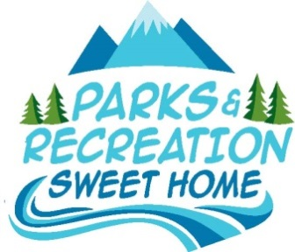
City of Sweet Home
Parks Board
City Hall
Annex Building
1140 12th Ave.,
Sweet Home, OR 97386

Park Board Minutes
July 18, 2016

Call to Order at 8:32am

Attendance: Chairperson Angela Clegg, Nancy Patton, Mariann Biteman, Andrew Allen (Remote) Councilor Dave Trask, Mayor Jim Gourley

Visitors: Bethany Stiner (University of Oregon), Sarah Hewitt, Linda Iljin, Elea Hewitt, Chase Boyd

Staff: Planning Assistant Katie Wilcox, Public Works Director Mike Adams

Absent: None

Welcoming and Introductions
The group went through introductions around the table.

Chairperson Nomination and Selection
Nancy Patton nominated Angela Clegg.
The board agreed unanimously that Angela Clegg should be appointed as Chairperson.
Angela Clegg accepted.

Introductions, Citizen Comments, and Submission of Inquiries, Ideas and Proposals
Nancy Patton asked about the status of signage. The group discussed signage such as rules and regulation, no smoking and interpretive. Mike Adams explained where they were at in the process. The group discussed wording the signs in a more positive way. They continued to discuss the effectiveness of signs and hoe to enforce the rules of the park. The group discussed fundraising ideas such as using the memorial brick program and selling custom shirts.

Sankey Park Plan
Bethany Stiner from the University of Oregon explained what her role is in the Sankey Park Plan. She explained the timeline of the process for creating the concept plan for Sankey Park. She explained that the goal is to create a design that the community and the Parks Board really support. She explained what the concept plan would consist of. She discussed the community outreach methods that have worked well in the past and how she would like to implement them. She went over the projected timeline and schedule for the scope of work. The group discussed what they wanted to see in the concept plan and ideas for the community outreach events.

Next Regular Parks Board Meeting – August 15, 2016 @ 8:30AM

