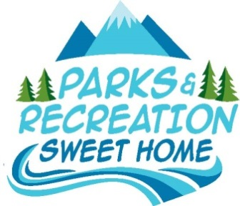
City of Sweet Home
Parks Board
City Hall
Conference Room
1140 12th Ave.,
Sweet Home, OR 97386

Park Board Minutes
June 20, 2016

Call to Order at 8:32am

Attendance: Chairperson Jane Hazen, Nancy Patton, Angela Clegg, Andrew Allen, Mariann Biteman
Councilor Dave Trask

Visitors: Councilor James Goble, Mayor Jim Gourley, Lisa Gourley, Linda Iljin

Staff: Planning Assistant Katie Wilcox, Public Works Director Mike Adams

Absent: None

Welcoming and Introductions
Chairperson Jane Hazen called the meeting to order and noted that there was a quorum.

The group went through introductions around the table.

Chairperson Jane Hazen mentioned that she wanted to make an adjustment to the future minutes, to put announcements and minutes after the introduction and proposal, to give people more time to achieve a quorum. She mentioned it has been an issue in the past and hopes to eliminate it.

Introduction/Submission of Inquiries, Ideas, & Proposals
Angela Clegg read from a prepared statement asking for the voluntary resignation of Chairperson Jane Hazen.

There group discussed actions of Chairperson Jane Hazen.

Nancy Patton, Angela Clegg, Andrew Allen and Councilor Dave Trask walked out of the meeting leaving no quorum.

Chairperson Jane Hazen adjourned the meeting at 8:40am.

Next Regular Parks Board Meeting – July 18, 2016 @ 8:30AM

